EXPT NO:03 | EDA-DATA INSPECTION AND ANALYSIS

AIM:
To inspect and analyze the Ocean Plastic Pollution dataset using Exploratory Data Analysis (EDA) to understand the data structure, identify patterns, detect missing values, and discover relationships between different student attributes.

PROCEDURE:
- Import Pandas, NumPy, Matplotlib, and Seaborn libraries.
- Load the Ocean Pollution dataset using Pandas.
- Display the first and last records using head() and tail().
- Check the number of rows and columns using shape.
- Display column names and data types using info().
- Check missing values using isnull().sum().
- Generate statistical summaries using describe().
- Check and identify duplicate records.
- Analyze important ocean pollution attributes such as Plastic Waste, Oil Spill, Marine Debris, Water Pollution Index, Microplastic Level, and Affected Marine Species.

CODE:

import pandas as pd
import numpy as np
import matplotlib.pyplot as plt
import seaborn as sns
df = pd.read_csv("Ocean_Pollution_Dataset.csv")

print("Ocean Pollution Dataset Loaded Successfully!")

print("\nFirst 5 Records:")
print(df.head())

print("\nLast 5 Records:")
print(df.tail())
print("\nDataset Shape:")
print(df.shape)
print("\nDataset Information:")
df.info()

print("\nColumn Names:")
print(df.columns)

print("\nData Types:")
print(df.dtypes)
print("\nMissing Values:")
print(df.isnull().sum())
print("\nStatistical Summary:")
print(df.describe())
print("\nNumber of Duplicate Records:")
print(df.duplicated().sum())

# Remove duplicates if present
df = df.drop_duplicates()

print("\nShape After Removing Duplicates:")
print(df.shape)
print("\nAverage Plastic Waste:")
print(df["Plastic_Waste_Tonnes"].mean())

print("\nAverage Oil Spill:")
print(df["Oil_Spill_Tonnes"].mean())

print("\nAverage Marine Debris:")
print(df["Marine_Debris_Tonnes"].mean())

print("\nAverage Water Pollution Index:")
print(df["Water_Pollution_Index"].mean())

print("\nAverage Microplastic Level:")
print(df["Microplastic_Level_mg_L"].mean())
print("\nAverage Affected Marine Species:")
print(df["Affected_Marine_Species"].mean())
plt.figure(figsize=(8, 5))

plt.hist(
df["Plastic_Waste_Tonnes"],
bins=10
)

plt.title("Distribution of Plastic Waste")
plt.xlabel("Plastic Waste (Tonnes)")
plt.ylabel("Frequency")
plt.grid(True)

plt.show()
ocean_pollution = df.groupby(
"Ocean"
)["Water_Pollution_Index"].mean()

plt.figure(figsize=(8, 5))

plt.bar(
ocean_pollution.index,
ocean_pollution.values
)

plt.title("Average Water Pollution Index by Ocean")
plt.xlabel("Ocean")
plt.ylabel("Water Pollution Index")
plt.xticks(rotation=25)

plt.show()
plt.figure(figsize=(8, 5))

plt.scatter(
df["Plastic_Waste_Tonnes"],
df["Affected_Marine_Species"]
)

plt.title("Plastic Waste vs Affected Marine Species")
plt.xlabel("Plastic Waste (Tonnes)")
plt.ylabel("Affected Marine Species")
plt.grid(True)

plt.show()
numeric_data = df.select_dtypes(
include=np.number
)

correlation = numeric_data.corr()

print("\nCorrelation Matrix:")
print(correlation.round(2))

plt.figure(figsize=(10, 7))

sns.heatmap(
correlation,
annot=True,
cmap="coolwarm",
fmt=".2f"
)

plt.title("Correlation Heatmap - Ocean Pollution Dataset")

plt.show()
print("\n--- FINDINGS ---")

highest_pollution_ocean = ocean_pollution.idxmax()

print(
"Ocean with highest average Water Pollution Index:",
highest_pollution_ocean
)

print(
"Highest Plastic Waste:",
df["Plastic_Waste_Tonnes"].max(),
"Tonnes"
)

print(
"Highest Oil Spill:",
df["Oil_Spill_Tonnes"].max(),
"Tonnes"
)

print(
"Highest Marine Debris:",
df["Marine_Debris_Tonnes"].max(),
"Tonnes"
)

print(
"Highest Affected Marine Species:",
df["Affected_Marine_Species"].max()
)

print("\nExperiment 3 completed successfully!")

Ocean Pollution Dataset Loaded Successfully!

First 5 Records:
Year Ocean Country Plastic_Waste_Tonnes Oil_Spill_Tonnes \
0 2015 Pacific Philippines 33795 1260
1 2015 Atlantic South Africa 62131 3319
2 2015 Indian China 80955 2833
3 2015 Arctic China 77150 589
4 2015 Southern India 49551 1928

Marine_Debris_Tonnes Water_Pollution_Index Microplastic_Level_mg_L \
0 47158 58.49 1.51
1 25023 62.26 1.62
2 14311 69.54 1.89
3 28118 69.29 1.68
4 20394 59.82 1.63

Affected_Marine_Species Cleanup_Cost_USD
0 104 19050
1 104 28579
2 93 30317
3 109 25154
4 102 20845

Last 5 Records:
Year Ocean Country Plastic_Waste_Tonnes Oil_Spill_Tonnes \
45 2024 Pacific USA 50217 516
46 2024 Atlantic USA 84617 912
47 2024 Indian Australia 77638 3547
48 2024 Arctic India 69293 3459
49 2024 Southern USA 74573 2157

Marine_Debris_Tonnes Water_Pollution_Index Microplastic_Level_mg_L \
45 14949 56.65 1.59
46 16805 72.17 2.10
47 10679 68.72 1.81
48 38124 63.53 1.78
49 46220 66.31 2.11

Affected_Marine_Species Cleanup_Cost_USD
45 114 16241
46 112 26228
47 96 30942
48 76 32727
49 88 31615

Dataset Shape:
(50, 10)

Dataset Information:
<class 'pandas.core.frame.DataFrame'>
RangeIndex: 50 entries, 0 to 49
Data columns (total 10 columns):
# Column Non-Null Count Dtype
--- ------ -------------- -----
0 Year 50 non-null int64
1 Ocean 50 non-null object
2 Country 50 non-null object
3 Plastic_Waste_Tonnes 50 non-null int64
4 Oil_Spill_Tonnes 50 non-null int64
5 Marine_Debris_Tonnes 50 non-null int64
6 Water_Pollution_Index 50 non-null float64
7 Microplastic_Level_mg_L 50 non-null float64
8 Affected_Marine_Species 50 non-null int64
9 Cleanup_Cost_USD 50 non-null int64
dtypes: float64(2), int64(6), object(2)
memory usage: 4.0+ KB

Column Names:
Index(['Year', 'Ocean', 'Country', 'Plastic_Waste_Tonnes', 'Oil_Spill_Tonnes',
'Marine_Debris_Tonnes', 'Water_Pollution_Index',
'Microplastic_Level_mg_L', 'Affected_Marine_Species',
'Cleanup_Cost_USD'],
dtype='object')

Data Types:
Year int64
Ocean object
Country object
Plastic_Waste_Tonnes int64
Oil_Spill_Tonnes int64
Marine_Debris_Tonnes int64
Water_Pollution_Index float64
Microplastic_Level_mg_L float64
Affected_Marine_Species int64
Cleanup_Cost_USD int64
dtype: object

Missing Values:
Year 0
Ocean 0
Country 0
Plastic_Waste_Tonnes 0
Oil_Spill_Tonnes 0
Marine_Debris_Tonnes 0
Water_Pollution_Index 0
Microplastic_Level_mg_L 0
Affected_Marine_Species 0
Cleanup_Cost_USD 0
dtype: int64

Statistical Summary:
Year Plastic_Waste_Tonnes Oil_Spill_Tonnes \
count 50.000000 50.000000 50.000000
mean 2019.500000 56279.960000 2593.280000
std 2.901442 21005.487118 1176.966666
min 2015.000000 18206.000000 516.000000
25% 2017.000000 38298.750000 1715.750000
50% 2019.500000 59887.500000 2878.500000
75% 2022.000000 72572.250000 3502.750000
max 2024.000000 89295.000000 4497.000000

Marine_Debris_Tonnes Water_Pollution_Index Microplastic_Level_mg_L \
count 50.000000 50.000000 50.000000
mean 29782.820000 61.625000 1.609000
std 11938.321122 8.928284 0.315823
min 10679.000000 38.890000 0.920000
25% 19785.500000 56.820000 1.412500
50% 30450.500000 62.270000 1.640000
75% 38126.250000 68.410000 1.827500
max 48976.000000 83.610000 2.110000

Affected_Marine_Species Cleanup_Cost_USD
count 50.000000 50.000000
mean 104.160000 25798.140000
std 12.357531 6516.797423
min 76.000000 11004.000000
25% 95.250000 20037.750000
50% 104.000000 25329.000000
75% 113.000000 30894.250000
max 127.000000 40619.000000

Number of Duplicate Records:
0

Shape After Removing Duplicates:
(50, 10)

Average Plastic Waste:
56279.96

Average Oil Spill:
2593.28

Average Marine Debris:
29782.82

Average Water Pollution Index:
61.625

Average Microplastic Level:
1.609

Average Affected Marine Species:
104.16
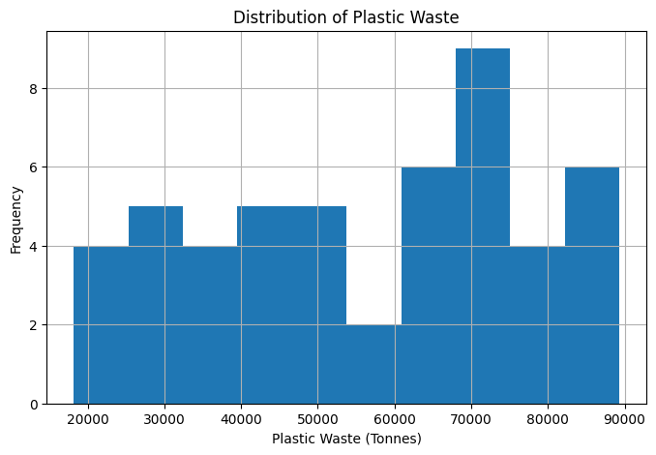
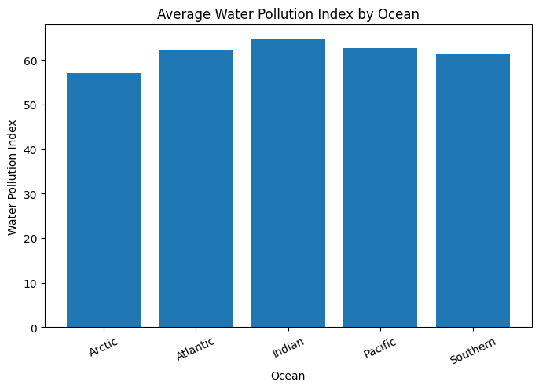
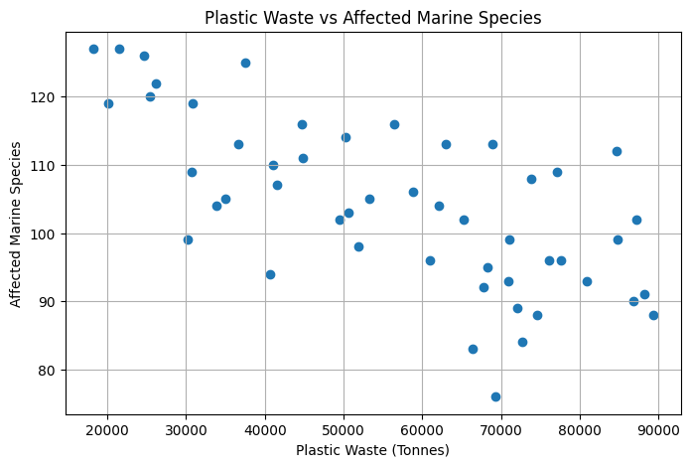

Correlation Matrix:
Year Plastic_Waste_Tonnes Oil_Spill_Tonnes \
Year 1.00 0.06 -0.05
Plastic_Waste_Tonnes 0.06 1.00 0.16
Oil_Spill_Tonnes -0.05 0.16 1.00
Marine_Debris_Tonnes -0.03 -0.23 -0.04
Water_Pollution_Index -0.05 0.84 0.14
Microplastic_Level_mg_L 0.10 0.86 0.19
Affected_Marine_Species -0.05 -0.68 -0.16
Cleanup_Cost_USD 0.01 0.82 0.63

Marine_Debris_Tonnes Water_Pollution_Index \
Year -0.03 -0.05
Plastic_Waste_Tonnes -0.23 0.84
Oil_Spill_Tonnes -0.04 0.14
Marine_Debris_Tonnes 1.00 -0.04
Water_Pollution_Index -0.04 1.00
Microplastic_Level_mg_L -0.16 0.67
Affected_Marine_Species 0.08 -0.71
Cleanup_Cost_USD 0.07 0.73

Microplastic_Level_mg_L Affected_Marine_Species \
Year 0.10 -0.05
Plastic_Waste_Tonnes 0.86 -0.68
Oil_Spill_Tonnes 0.19 -0.16
Marine_Debris_Tonnes -0.16 0.08
Water_Pollution_Index 0.67 -0.71
Microplastic_Level_mg_L 1.00 -0.50
Affected_Marine_Species -0.50 1.00
Cleanup_Cost_USD 0.75 -0.61

Cleanup_Cost_USD
Year 0.01
Plastic_Waste_Tonnes 0.82
Oil_Spill_Tonnes 0.63
Marine_Debris_Tonnes 0.07
Water_Pollution_Index 0.73
Microplastic_Level_mg_L 0.75
Affected_Marine_Species -0.61
Cleanup_Cost_USD 1.00
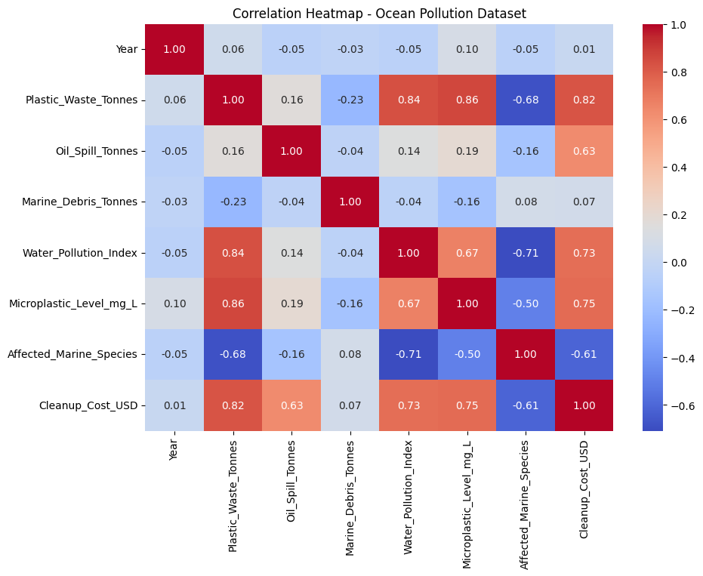

--- FINDINGS ---
Ocean with highest average Water Pollution Index: Indian
Highest Plastic Waste: 89295 Tonnes
Highest Oil Spill: 4497 Tonnes
Highest Marine Debris: 48976 Tonnes
Highest Affected Marine Species: 127

Experiment 3 completed successfully!
Result:

